|  |
| --- |
| [14/12/2024] |

|  |
| --- |
| Manufacturing Downtime Project |

# Team

[Name 1]

[Name 2]

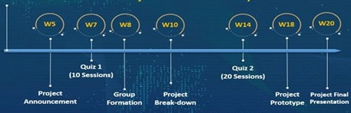

# Data Cleaning and Preprocessing

Data Preprocessing: Clean and preprocess the data using Power BI

**Deliverables:** Cleaned dataset ready for analysis.

## **Steps**

The data consists of 4 Tables of data and 1 table as a data dictionary

* **Downtime factors Sheet**
* Loaded sheet and selected Downtime factors Sheet
* Promoted header and changed Type
* Confirmed by data view NO Errors and NO Empty data
* **Line productivity Sheet**
* Loaded sheet and selected Downtime factors Sheet
* Promoted header and changed Type
* Confirmed by data view NO Errors and NO Empty data
* KEEP ONLY Required Columns
* Calculated Actual Period in minutes to:
* get this values and use it for further calculations
* No negative values confirm no errors in start and end times Entry
* **Line downtime Sheet**
* Loaded sheet and selected Line factors Sheet
* Promoted header but found extra undesired row.
* removed 1 top row first and Promoted header
* Confirmed by data view NO Errors and NO Empty data in Batch but all other data have empty values
* Empty values are due to each factor data is displayed in separate column
* Unpivot 12 factors in two column factor and Downtime in minutes
* Confirmed by data view NO Errors and NO Empty data in all remaining columns
* **Products Sheet**
* Loaded sheet and selected Products Sheet
* Promoted header and changed Type
* Confirmed by data view NO Errors and NO Empty data
* To use Size in calculations, it is better to use it in single unit. SO, we will change all into ml and keep necessary columns only
* **ERD (Entity Relationship Diagram)**

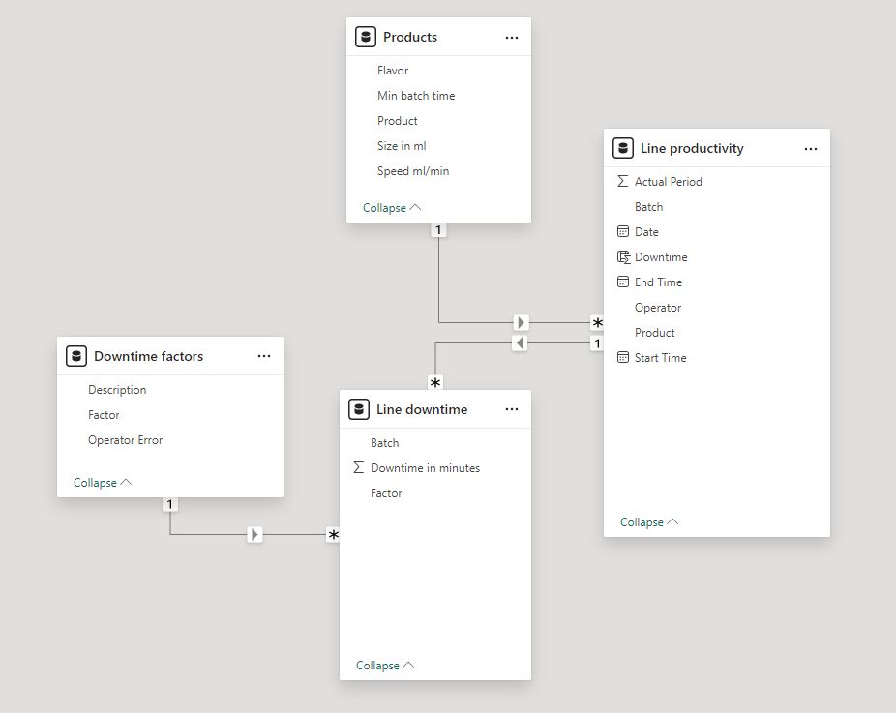

**PK**

**PK**

**PK**

**FK**

**FK**

**FK**

# Analysis Questions Phase

Determine Data Analysis Questions: Determine all possible analysis questions that can be deducted from the given dataset and would be of interest to the organization’s decision makers.

**Deliverables:** Set of analysis questions that can be answered via the dataset.

## **Steps**

* **All Available Data**
* Downtime [Factor – Operator Error (YES/NO)]
* Time [ Date – Start – End – Actual Period ]
* Unique [ Batch – Product – Operator - Flavor]
* **To check Downtime (Sum, Average, Max, Min, Mode) vs:**
* Factor
* Operator Error (YES/NO)
* Operator (Name)
* Batch
* Product
* Flavor

# Dashboard Phase

Build Dashboard: Build a Power BI dashboard that visualize the answers to the asked questions.

**Deliverables:** Power BI dashboard.

## **Steps**

* Every one to record every step he makes

# Final Presentation

Prepare a report and presentation summarizing the project work, including data analysis, model development, and deployment.

**Deliverables:** Final report and presentation.

## **Steps**

* Every one to record every step he makes

# Discussion

[Summarize the discussion for each issue, state the outcome, and assign any action items.]

# Summary

[Summarize the status of each area/department.]